Adult Mosquito Treatment Area for
UPPER FREEHOLD

Upper Freehold: Residential developments along Trotter Way and Long Acre Drive.
September 18th 7:00 PM – 10:00 PM

In the event of unfavorable weather conditions, the treatment will be rescheduled for September 19th 7:00 PM – 10:00 PM

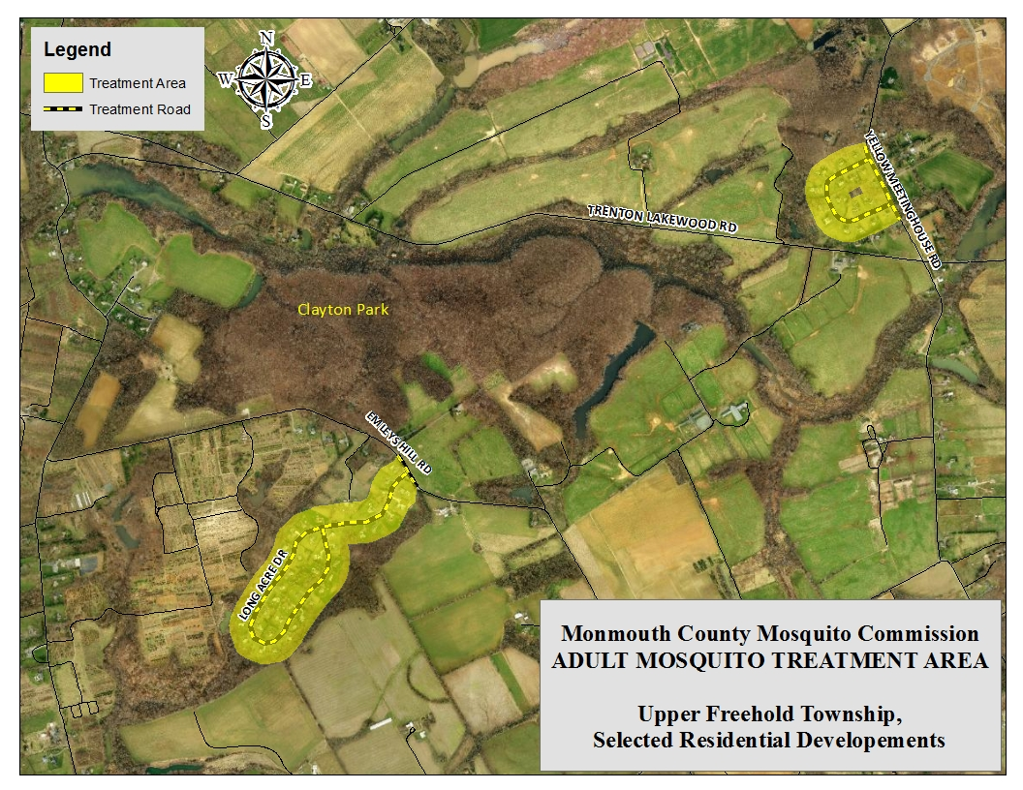Current schedules and cancellations can also be heard on the Monmouth County Mosquito Commission hotline at (732) 578-1600.

The Commission will conduct targeted treatments to reduce adult mosquito populations in the yellow-highlighted areas in the map above using truck-mounted ULV (Ultra Low Volume) machines. The product being applied for the control of adult mosquitoes is a pyrethroid-based pesticide, which goes by the brand name Duet. Duet is registered for residential adult mosquito control by the US Environmental Protection Agency and NJ Department of Environmental Protection.
The USEPA does not require relocating or taking special precautions during mosquito control spraying; however, the Commission realizes that some people may prefer to avoid or minimize exposure by practicing common sense precautions such as staying indoors, keeping windows shut, and turning window air conditioners and window fans off during spraying.
Despite the minimal risks as a public health pesticide, pyrethroids are potentially toxic to fish. Considering the ultra low application rate, fish populations should not be affected. In fact, the Commission has received no documented reports of any fish kills following any adulticiding applications using pyrethroids. To minimize exposure, property owners can cover fishponds with a tarp or bring the fish indoors.
The MCMEC advises all residents to avoid mosquito bites by wearing protective clothing such as long pants and long-sleeved shirts and use of insect repellent when outdoors during periods of adult mosquito activity.

