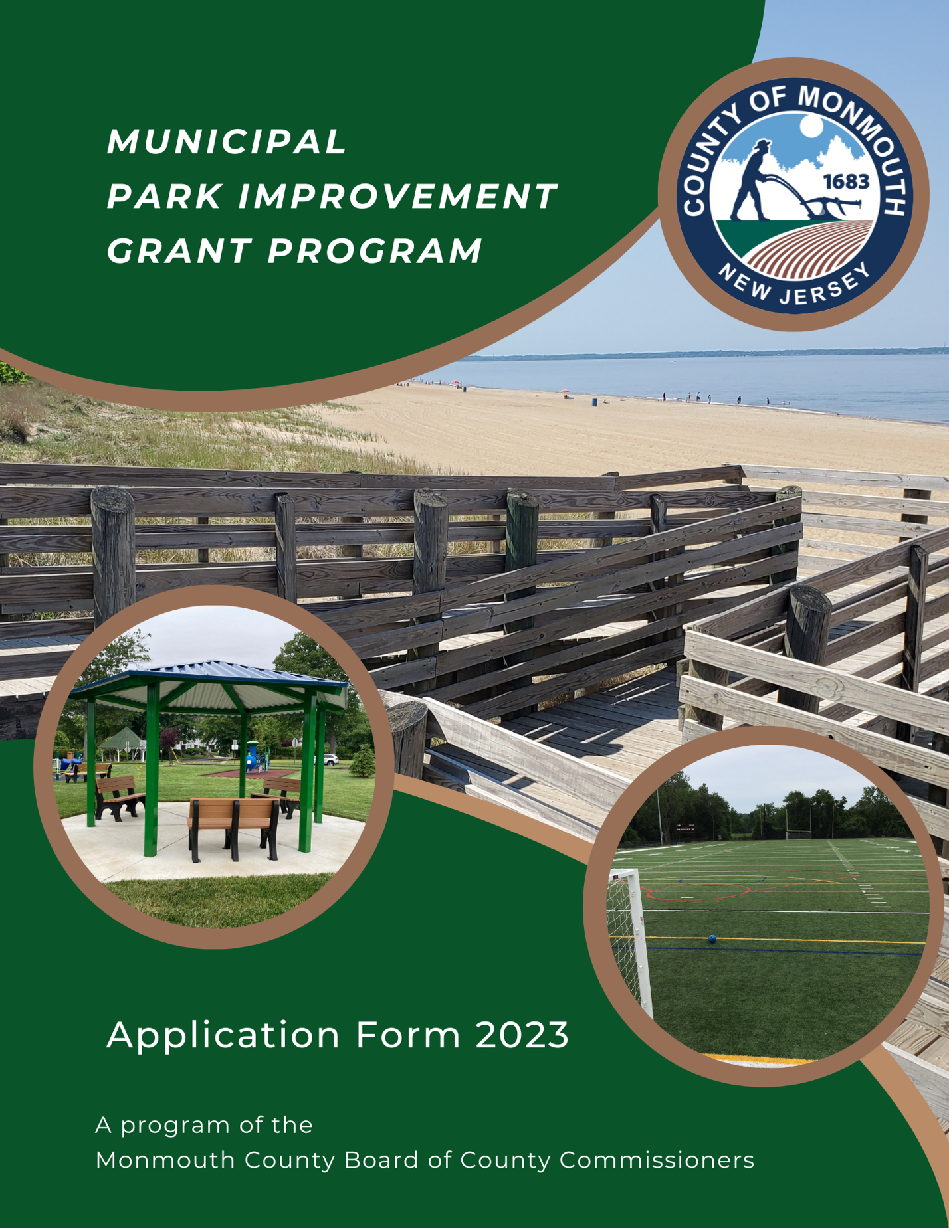

Monmouth County Municipal Park Improvement Grant Program

Official Use
Date Received:
Application #:

Application Cover Page

2023 APPLICATION DEADLINE: 4:00 PM ON THURSDAY, JULY 13, 2023

Submission Instructions: Send one (1) hard copy of this completed application with originals of the required attachments to this mailing address by the above listed deadline:

Monmouth County Park System/Municipal Open Space Grant Program
805 Newman Spring Road
Lincroft, NJ 07738

Additionally, send a scanned version of the completed application containing all attachments as one PDF file emailed to municipal.grants@co.monmouth.nj.us.

Applicant Information
Name of Municipality: Click or tap here to enter text.
Name of Municipal Contact Person (this should match the mail contact on the resolution): Click or tap here to enter text.
Municipal Mailing Address: Click or tap here to enter text.
Email Address of Municipal Contact Person: Click or tap here to enter text.

Park Improvement Project Information
Project Name: Click or tap here to enter text.
Project Location Address: Click or tap here to enter text.
Please list all block and lots for the entire project area (the entire park area is the project area): Click or tap here to enter text.

Total Project Cost: Click or tap here to enter text.

Total Grant Funding Request Amount (round to the nearest thousand. Note this amount cannot exceed $500,000): Click or tap here to enter text.

Application Form

Please type your responses into the fillable text boxes provided after each question. Print one hard-copy of this completed form with your required hardcopy submission and provide a PDF of this form electronically to municipal.grants@co.monmouth.nj.us.

1. Project Description

a. Describe the scope of the project. If the funding request is for less than the entire project scope, this must be explained. Please provide a narrative description of the project below:
Click or tap here to enter text.

b. Provide a list of project elements below:
Click or tap here to enter text.

c. Is the subject site owned and maintained by the municipality?
No☐Yes☐
All project sites must be owned by the applicant municipality, or the municipality must hold a long-term lease for a term of at least 25 years beyond the grant award, or other instruments extending for substantially 25 years beyond the grant award where a third-party governmental entity is also a party. In all cases, the site must be under the control of the applicant municipality. When project sites are not owned in fee simple by the municipality, additional agreements or covenants may be required. If the property is leased, a copy of the lease must be provided to verify the length of the lease.

If yes, provide a brief summary of the property ownership in the text box below.
Click or tap here to enter text.

If no, please provide a brief summary of the lease or other use agreement:
Click or tap here to enter text.

d. Is the entire park area listed on the Recreation Open Space Inventory (ROSI) through the State of New Jersey?
Yes☐No☐
Please provide a brief explanation if applicable.
Click or tap here to enter text.

e. Does the proposed project include dredging a body of water?
No ☐Yes ☐
If yes, please identify the body of water. Please also specify if the body of water is located within the municipal park or located adjacent to the municipal park.
Click or tap here to enter text.

f. Please describe the estimated schedule for completion of the project and any plans to phase the project if applicable. The timetable should include calendar dates, not spans of time. Note: All funded projects must be completed within thirty (30) months of grant award:
Click or tap here to enter text.

g. Are there any other anticipated funding partners for this project?
Yes ☐No☐
If yes, please explain the amount of funding that will be provided. Provide specific information as to the park elements that will be funded and any restrictions that may apply.
Click or tap here to enter text.

2. Site Conditions & Natural Features

a. Describe the physical condition of the property, both natural and man-made features. Natural features include the presence or absence of wetlands, steep slopes, flood plains, habitat types, fields and forests, open water, streams and natural drainage features. Man-made features include buildings, parking lots, recreational facilities and man-made drainage features. Include a statement about any known environmental hazards; if none are known, state that.
Click or tap here to enter text.

b. Describe the compatibility of the project with the surrounding land use and zoning requirements. Explain how the current and surrounding land uses will positively and/or negatively impact the proposed use and vice versa, also include impacts to circulation and existing, approved local planning documents. Identify any natural, cultural or historic features to be preserved, enhanced or removed by the project.
Click or tap here to enter text.

3. Recreation/Open Space Program
a. Describe the specific park and recreation objectives for the project. Explain how those objectives meet the grant program goals (see Program Manual for more information about the program goals) and local planning goals. Describe attainment of grant program goals through the proposed project.
Click or tap here to enter text.

b. Explain how the project complements existing recreation and open space. Describe the municipality’s overall recreation/open space needs or deficiencies. Explain how the project will fulfill those needs. Explain why this project was chosen over other possible municipal recreation/open space projects. Be specific and reference any existing, approved local planning documents. Describe how the project complements existing recreation and open space. Describe the physical relationship of the project site to other state, county, non-profit or municipal recreation and open space (if applicable).
Click or tap here to enter text.

c. Describe how the proposed project meets local recreation needs.
Click or tap here to enter text.

d. Explains how the project is consistent with adopted plans. Describe how the project is consistent with local and regional plans.
Click or tap here to enter text.

Required attachments:
Check the box to indicate that it is attached to the hardcopy submission and sent electronically.
☐Concept Plan: Provide a copy of the concept plans prepared by a design professional. The concept plan must be of sufficient detail to legibly identify individual project elements and show the location of the proposed improvements within the park property; for larger parks, it may be necessary to provide two maps at different scales to show both the entire park and its boundaries and the proposed improvements within the park. For phased projects, each phase must be wholly distinct, and the plans must articulate what is existing, what is currently being proposed for funding, and what is to be completed in future phases.

☐Project Budget: Provide a current estimate of project costs prepared by a design professional. The project budget should be organized according to project elements with the quantities that served as the basis for the estimates provided. While the budget estimate may include ineligible costs as an indicator of the municipality’s financial commitment to the project, they should be listed separately. Only eligible costs should be included in determining the total construction cost which is the basis of any grant award. See below for additional clarification regarding eligible and ineligible costs and the sample budget for development projects provided.

☐Lease or other long-term use agreement (if applicable) to confirm municipal control of the property. If the property is leased, a copy of the lease must be provided to verify the length of the lease. For projects that are on property subject to a long-term lease or other agreement, the applicant must provide written proof of the consent of the lessor/owner for development of the project.

☐Aerial Map: Attach a color aerial image of the entire property/project area.

☐Tax Map: Attach a tax map showing all block and lots for the entire park area.

☐Natural Resource Map: Attach a natural resource map that shows any floodplains, wetlands, forests, streams, and threatened or endangered species habitat for the entire park area.

Public hearing on the project: Date of hearing: _________
☐Certified copy of the minutes with the project scope summary presented at hearing and reflected in the minutes.

Affidavit of notice of the public hearing:
Notice Requirements:
☐Published 10 days in advance. Date of notice: _______
☐States time and place of hearing
☐States purpose of hearing
☐Identifies project by name
☐Identifies project by address
☐Identifies project by block and lot
☐Public hearing notice provided on the municipal website.
Please list the url:Click or tap here to enter text.

Municipal resolution with required components. *Must use mandatory resolution language provided below.
☐States requested funding amount ____________
☐Describes property by name, address, and block and lot __________________
☐Lists total project cost _____________________________________________
☐Designates contact person by name and title ___________________________
☐States municipal commitment to project.
☐Designates signatory by name and title _________________________________

☐Copy of park area deed restrictions (if applicable): ______________________________

☐Optional: Letters of commitment from project partners (if applicable): _________________

Questions and correspondence regarding the Monmouth County Municipal Park Improvement Grant Program should be addressed to the Monmouth County Park System, Acquisition and Design Office, Attn: Municipal Open Space Program, 805 Newman Springs Road, Lincroft, NJ 07738. The Program Administrator can be contacted by telephone at 732-609-4751 or by e-mail at municipal.grants@co.monmouth.nj.us.

MODEL DOCUMENTS AND ADDITIONAL APPLICATION INFORMATION

SAMPLE PARK IMPROVEMENT PROJECT BUDGET

PROJECT ELEMENT | QUANTITIES | ESTIMATED COST
Site clearing, earthwork, soil erosion control |  | $90,000.00
Lighting | 5 poles and fixtures | $25,000.00
Walkways/trails | 2,000 lf | $121,000.00
Fencing | 1,000 lf split rail | $18,000.00
Soccer field | 1 | $120,000.00
Basketball courts | 2 | $45,000.00
Parking | 40 cars | $200,000.00
Landscaping | 20 shade trees | $8,000.00
Benches | 8 | $6,400.00
TOTAL CONSTRUCTION COST |  | $633,400.00
*Please note: Budget contingency amounts will not be accepted above 15%.

Eligible Park Improvement Projects
Please note the following grant eligibility conditions:
- All projects must be for park, recreation, historic preservation or open space purposes.
- A deed of open space easement or similar instrument restricting the use of the project site to these purposes will be required as a condition of award.
- Applications for projects that diversify or expand recreation opportunities will be favored over applications that replace aged or substandard facilities or address issues of maintenance.
- Degree of public access will also be considered.
- Building new facilities and improving existing facilities through demolition, renovation and/or stabilization will be considered as eligible.
- Dredging of public bodies of water is also considered eligible if located within a municipal park or provides access to a municipal park.
- All project sites must be owned by the applicant municipality, or the municipality must hold a long-term lease for a term of at least 25 years beyond the grant award, or other instruments extending for substantially 25 years beyond the grant award where a third-party. In all cases the site must be under the control of the applicant municipality. When project sites are not owned in fee simple by the municipality, additional agreements or covenants may be required. Fees for use of funded facilities are permissible.

Ineligible Development and Redevelopment Projects
The following conditions will deem projects as ineligible:
- Projects that have restricted public access unless full access is determined to be detrimental to natural resources.
- Activities that will cause adverse impacts to environmental, scenic, historic or pre-existing park resources.
- Projects or project elements that have previously received funding through the Monmouth County Municipal Open Space Grant Program within the last 10 years and remain in reasonable working order.

Allowable Project Costs for Development and Redevelopment Projects
For development and redevelopment projects, the allowable grant amount will be based on the actual construction costs of the approved project elements. Project costs will not be allowed as set forth below under the heading “Disallowable Project Costs for Development and Redevelopment Projects”.

Disallowable Project Costs for Development and Redevelopment Projects
The following costs will not be covered with program funds and should be excluded from the total project cost used to determine the grant request amount:
- Operational and maintenance costs for facilities or projects.
- Equipment – e.g., trucks, tractors, boats, tables, chairs or other movable, expendable or disposable items. (Fixtures will be allowed if determined to be a necessary component of the facility.)
- Soft costs – e.g., engineering, architectural, surveys, permits, environmental audits, administration or operation related to the project, in-kind services including salaries or wages of employees of the applicant.
- Contingencies in excess of 15% of proposed project budget.
- Any costs incurred prior to the submission of the application; the issuance of a purchase order or the award of a contract shall constitute the incurrence of costs.

Applicants are responsible for completing the entire scope of the project or risk having grant funding reduced or rescinded. All elements of the project scope must be complete to ensure full re-imbursement of any awarded grant funds. Applicants should consider phasing larger projects, completing an initial phase under one round of grants, and seeking additional funding for subsequent phases under subsequent rounds. Project phasing must be proposed with the initial project proposal and subsequent grant applications are not guaranteed funding in subsequent rounds.

Public Hearing Information and Minutes:
Provide a certified copy of the minutes from the public hearing on the grant application and an affidavit of notice; these must be included in the application for it to be considered complete and eligible for funding. The hearing must be held prior to submission of the application, but no more than twelve (12) months prior. The hearing may be held in conjunction with a regularly scheduled municipal meeting, but this is not mandatory. The notice of the hearing must be published as a legal notice or display advertisement at least ten (10) days prior to the hearing date in a local newspaper providing a local circulation in the municipality in which the project is located and on the municipal website. The notice must state the purpose of the hearing and identify the project by name, street address, and all blocks and lots that are part of the park property, as well as the time and place of the hearing. The minutes must reflect that a project scope summary was presented at the hearing. Submissions for which a hearing has not been held prior to the application deadline will be deemed ineligible.

Municipal Resolution:
Complete and submit a certified resolution of the governing body using the format provided here (applicants may not modify the language in the municipal resolution and must identify the project by name, street address, and all blocks and lots that are part of the park property). This resolution memorializes the governing body’s approval of the project, authorizes the municipality’s financial participation in the project, authorizes the signing and execution of all required documents, and indicates its readiness to proceed with the project in terms of matching funds. Submissions lacking an authorizing resolution will be deemed ineligible.

Note: The language contained in the Municipal Resolution must be used as it appears in this document. Modifications to the language are not permitted.

MUNICIPAL RESOLUTION LANGUAGE

WHEREAS, the Monmouth County Board of County Commissioners has approved an Open Space Trust Fund and established a Municipal Open Space Program to provide Program Grant funds in connection with municipal acquisition of lands for County Park, recreation, conservation and farmland preservation purposes, as well as for County recreation and conservation development and maintenance purposes; and

WHEREAS, the Governing Body of ____________________________(name of municipality) desires to obtain County Open Space Trust Funds in the amount of $_________________ to fund _____________________________________________(name of project, address, lot, & block); and

WHEREAS, the total cost of the project including all matching funds is $______________; and

WHEREAS, the _____________________(name of municipality) is the owner of and controls the project site.

NOW, THEREFORE, BE IT RESOLVED BY ____________________________________ (name of the governing body) THAT:

- _____________________ (name and title of authorized official) or his/her successor is authorized to (a) make an application to the County of Monmouth for Open Space Trust Funds, (b) provide additional application information and furnish such documents as may be required for the Municipal Open Space Grants Program and (c) act as the municipal contact person and correspondent of the above named municipality; and

- The ___________________ (name of municipality) is committed to this project and will provide the balance of funding necessary to complete the project as described in the grant application in the form of non-county matching funds as required in the Policy and Procedures Manual for the Program; and

- If the County of Monmouth determines that the application is complete and in conformance with the Monmouth County Municipal Open Space Program and the Policy and Procedures Manual for the Municipal Grants Program adopted thereto, the municipality is willing to use the approved Open Space Trust Funds in accordance with such policies and procedures, and applicable federal, state, and local government rules, regulations and statutes thereto; and

- ______________________ (name and title of authorized official) or his/her successor is hereby authorized to sign and execute any required documents, agreements, and amendments thereto with the County of Monmouth for the approved Open Space Trust Funds; and

- This resolution shall take effect immediately.

CERTIFICATION
I, ________________________ do hereby certify that the foregoing is a true copy of a resolution adopted by the Governing Body of ________________________ (name of municipality) at a meeting held on the _____ day of ________________, 20___.
In Witness Whereof, I have hereunder set my hand and official seal of the municipality this ____ day of ________________, 20___.

